5.Make a registration form and help the organization to collect their employee’s details like, employer’s name, id, address, department, mobile number and select their city from the drop down list box using HTML and CSS.
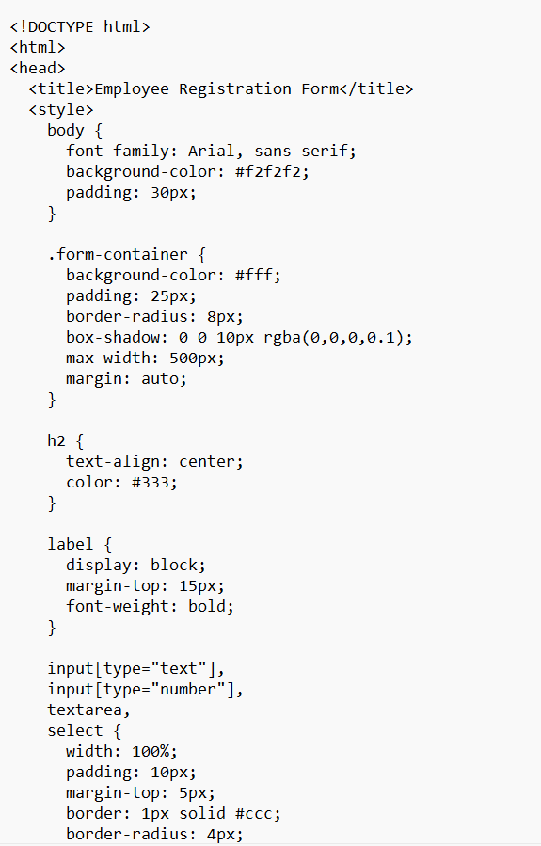

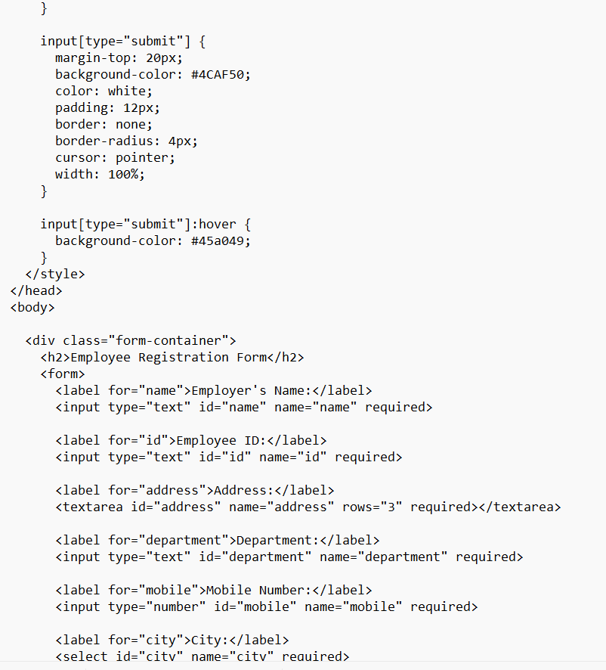

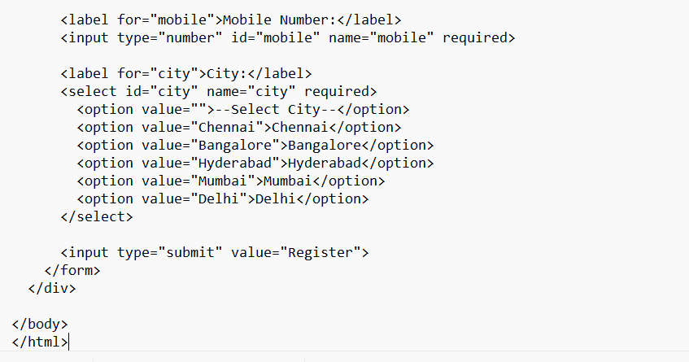
Output
